Selux Group to undergo strategic restructuring in Europe

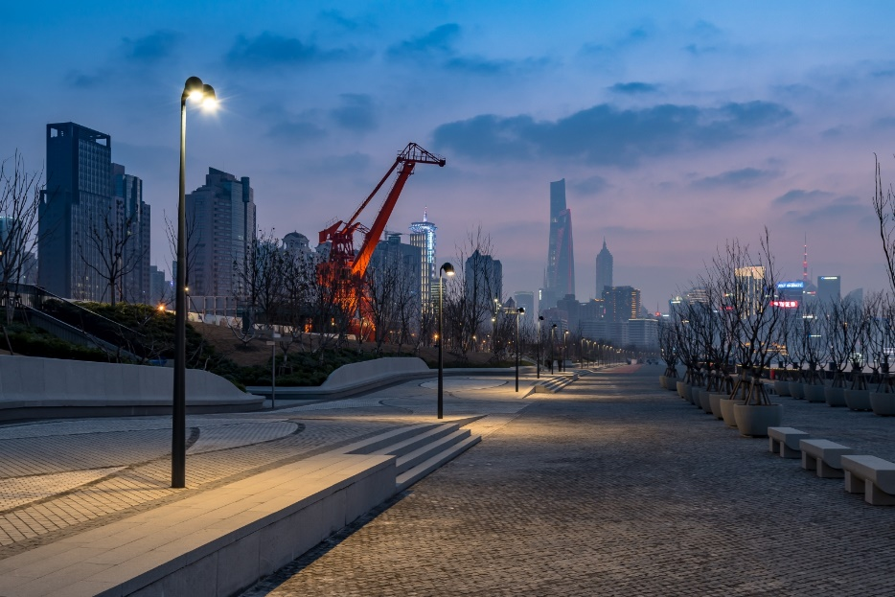

Berlin, July 2018 - With its professional lighting solutions, the Selux Group will in future be concentrating on its successful exterior business within Europe.

To enhance its innovative strength, the international Selux Group will in future be focussing its activities on its successful exterior applications area. Selux can look back on more than 70 years of operating experience, with around 500 staff members in 13
countries, as well as production sites in Germany, France and the USA.
Selux Corporation in the USA will continue unchanged with its successful activity in interior and exterior business.

In Europe the focus will be on the successful exterior business segment, creating smart lighting for the smart city applications of tomorrow. The heart of this restructuring will be intelligent networking of urban lighting as an open, modular infrastructure. Selux
products like the new Lif light column with its innovative, smart elements point the way forward – as does its Smart Parking area in Berlin, where customers can experience Selux smart lighting already today live and in person.

“Our modular products are ideal for the integration of smart functions, which we implement both professionally and in a future-compatible manner,” says Ralf P. Knorrenschild, Executive Board Member, Selux AG, of the company’s innovative focus.

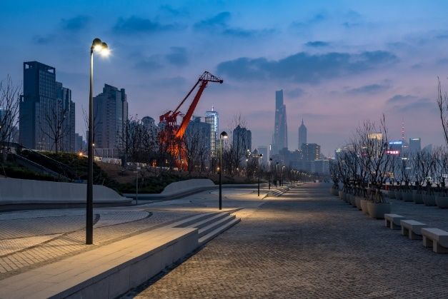
The East Bund waterfront, Shanghai, Autumn 2017
Photographer Zilu Wang

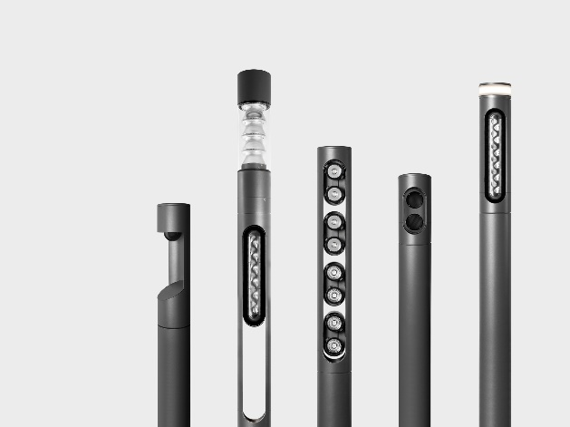
Like nodes in extensive digital networks in smart cities, smart lighting ensures a new role for lighting technology, for which Selux is optimally prepared. Products like the Lif provide optimal prerequisites for the integration of smart functions.

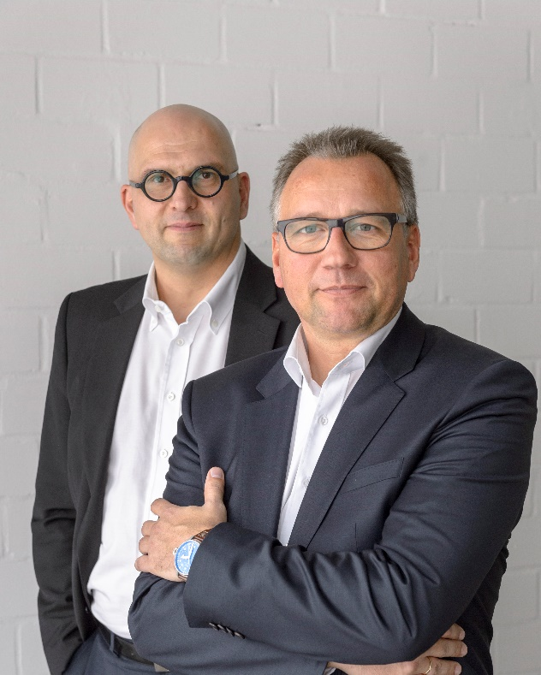
The Executive Board Team at the Berlin luminaire manufacturer Selux comprises Jürgen Hess (left) and Ralf Knorrenschild.
Photographer: Maurice Weiss

February 2017 http://www.selux.com

July 2018, www.selux.com

